import numpy as np
import pandas as pd
import matplotlib.pyplot as plt
import seaborn as sns
import plotly.graph_objects as go
import plotly.express as px
plt.style.use('seaborn')
from collections import Counter
from sklearn.preprocessing import StandardScaler
from sklearn.model_selection import train_test_split,GridSearchCV
from sklearn.metrics import confusion_matrix,accuracy_score,roc_curve,roc_auc_score,classification_report,f1_score
from sklearn.linear_model import LogisticRegression
from sklearn.naive_bayes import GaussianNB
from xgboost import XGBClassifier
from sklearn.ensemble import RandomForestClassifier
from sklearn.tree import DecisionTreeClassifier
from sklearn.neighbors import KNeighborsClassifier
from sklearn.naive_bayes import GaussianNB
from sklearn.svm import SVC
from mlxtend.classifier import StackingCVClassifier
import itertools
from sklearn.dummy import DummyClassifier
from sklearn import metrics
df = pd.read_csv('heart.csv')
df.head()
age sex cp trestbps chol fbs restecg thalach exang oldpeak slope \
0 63 1 3 145 233 1 0 150 0 2.3 0
1 37 1 2 130 250 0 1 187 0 3.5 0
2 41 0 1 130 204 0 0 172 0 1.4 2
3 56 1 1 120 236 0 1 178 0 0.8 2
4 57 0 0 120 354 0 1 163 1 0.6 2
ca thal target
0 0 1 1
1 0 2 1
2 0 2 1
3 0 2 1
4 0 2 1
df.describe()
age sex cp trestbps chol fbs \
count 303.000000 303.000000 303.000000 303.000000 303.000000 303.000000
mean 54.366337 0.683168 0.966997 131.623762 246.264026 0.148515
std 9.082101 0.466011 1.032052 17.538143 51.830751 0.356198
min 29.000000 0.000000 0.000000 94.000000 126.000000 0.000000
25% 47.500000 0.000000 0.000000 120.000000 211.000000 0.000000
50% 55.000000 1.000000 1.000000 130.000000 240.000000 0.000000
75% 61.000000 1.000000 2.000000 140.000000 274.500000 0.000000
max 77.000000 1.000000 3.000000 200.000000 564.000000 1.000000
restecg thalach exang oldpeak slope ca \
count 303.000000 303.000000 303.000000 303.000000 303.000000 303.000000
mean 0.528053 149.646865 0.326733 1.039604 1.399340 0.729373
std 0.525860 22.905161 0.469794 1.161075 0.616226 1.022606
min 0.000000 71.000000 0.000000 0.000000 0.000000 0.000000
25% 0.000000 133.500000 0.000000 0.000000 1.000000 0.000000
50% 1.000000 153.000000 0.000000 0.800000 1.000000 0.000000
75% 1.000000 166.000000 1.000000 1.600000 2.000000 1.000000
max 2.000000 202.000000 1.000000 6.200000 2.000000 4.000000
thal target
count 303.000000 303.000000
mean 2.313531 0.544554
std 0.612277 0.498835
min 0.000000 0.000000
25% 2.000000 0.000000
50% 2.000000 1.000000
75% 3.000000 1.000000
max 3.000000 1.000000
df.shape
(303, 14)

Variable Descriptions
- age: age in years
- sex: sex (1 = male; 0 = female)
- cp: chest pain type - Value 1: typical angina, Value 2: atypical angina, Value 3: non-anginal pain, Value 4: asymptomatic
- trestbps: resting blood pressure (in mm Hg on admission to the hospital)
- chol: serum cholestoral in mg/dl

- fbs: (fasting blood sugar > 120 mg/dl) (1 = true; 0 = false)
- restecg: resting electrocardiographic results- Value 0: normal, Value 1: having ST-T wave abnormality (T wave inversions and/or ST elevation or depression of > 0.05 mV), Value 2: showing probable or definite left ventricular hypertrophy by Estes' criteria
- thalach: maximum heart rate achieved
- exang: exercise induced angina (1 = yes; 0 = no)
- oldpeak = ST depression induced by exercise relative to rest
- slope: the slope of the peak exercise ST segment- Value 1: upsloping, Value 2: flat, Value 3: downsloping
- ca: number of major vessels (0-3) colored by flourosopy
- thal: 3 = normal; 6 = fixed defect; 7 = reversable defect
- target: 1 = disease, 0 = no disease

Variable Types
- Continuous - age, trestbps, chol, thalach, oldpeak
- Binary - sex, fbs, exang, target
- Categorical - cp, restecg, slope, ca, thal
y = df.target.value_counts()
x = ['Disease','No Disease']
title = go.layout.Title(text='Target Variable (Heart Disease) Distribution')
layout = go.Layout(title=title)
data = go.Bar(x=x,y=y,text=y,textposition='auto')
fig = go.Figure(data=[data],layout=layout)
fig.update_xaxes(title_text='Target')
fig.update_yaxes(title_text='Number of Individuals')
fig.show()

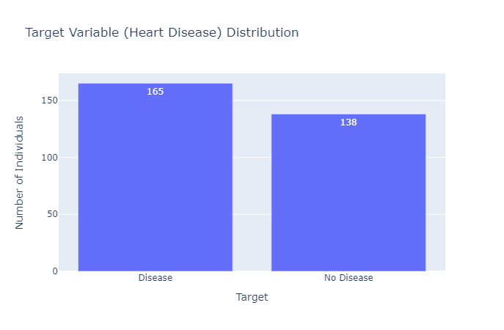
fig = px.histogram(df,x='age',color_discrete_sequence=['coral'])
fig.update_xaxes(title_text='Age')
fig.update_yaxes(title_text='Count')
fig.update_layout(title_text='Distribution of Age.')
fig.show()
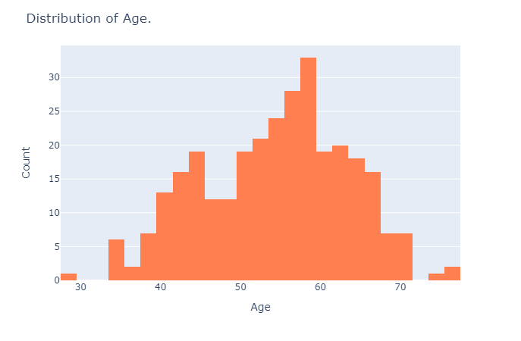

female = df[df['sex']==0]
female_count = female.target.value_counts()
male = df[df['sex']==1]
male_count = male.target.value_counts()
male_data = go.Bar(name='male',x=male_count.index,y=male_count,text=male_count,textposition='auto')
female_data = go.Bar(name='female',x=female_count.index,y=female_count,text=female_count,textposition='auto')
fig = go.Figure(data=[male_data,female_data])
fig.update_xaxes(title_text='Target')
fig.update_yaxes(title_text='Count')
fig.update_layout(title_text='Distribution of Sex According to Target Variable',barmode='group')
fig.show()
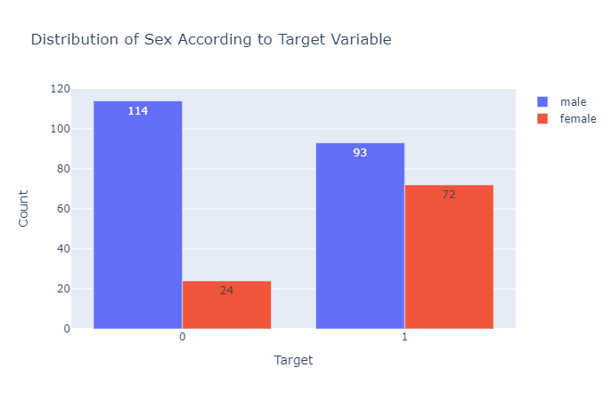
cp = ['Typical Angina','Atypical Angina','Non-Anginal Pain','Asymptomatic']

cp_y0 = df[df['target']==0].cp.value_counts()
cp_y1 = df[df['target']==1].cp.value_counts()
non_disease_data = go.Bar(name='No Disease',x=cp,y=cp_y0)
disease_data = go.Bar(name='Disease',x=cp,y=cp_y1)
fig = go.Figure(data=[non_disease_data,disease_data])
fig.update_xaxes(title_text='Chest Pain Type')
fig.update_yaxes(title_text='Count')
fig.update_layout(title_text='Distribution of Target Variable According to Chest Pain.',barmode='group')
fig.show()
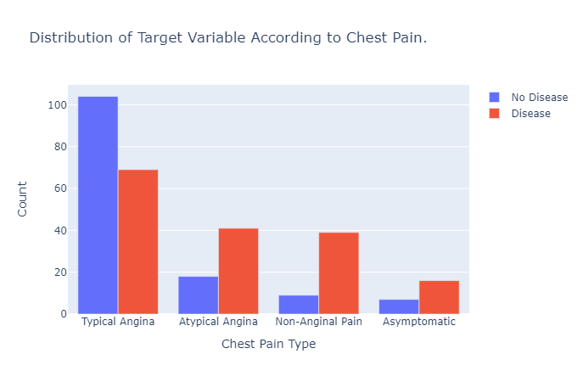
Fasting blood sugar (FBS) is a diabetes indicator with FBS >120 mg/d is considered diabetic (True). Here, we see that the number for class True, is lower compared to class False. However, if we look closely, there are higher number of heart disease patient without diabetes. This provide an indication that fbs might not be a strong feature differentiating between heart disease an non-disease patient.
disease_values = df[df['target']==1].fbs.value_counts()
no_disease_values = df[df['target']==0].fbs.value_counts()
x = ['No Blood Sugar','Blood Sugar']
disease_data = go.Bar(name='Disease',x=x,y=disease_values,textposition='auto')
no_disease_data = go.Bar(name='No Disease',x=x,y=no_disease_values,textposition='auto')
fig = go.Figure(data=[disease_data,no_disease_data])
fig.update_layout(title_text='Distribution of Target Variable According to Fasting Blood Sugar',barmode='group')
fig.update_xaxes(title_text='Fasting Blood Sugar(FBS)')
fig.update_yaxes(title_text='Count')
fig.show()
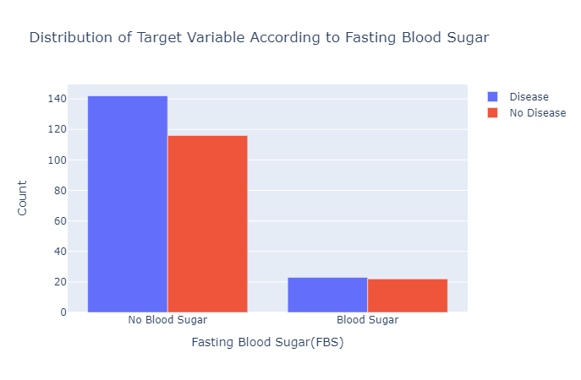
df.thal.value_counts()
2 166
3 117
1 18
0 2
Name: thal, dtype: int64
df[df['thal']==0] = np.NaN
df.ca.value_counts()
0.0 173
1.0 65
2.0 38
3.0 20
4.0 5
Name: ca, dtype: int64
df[df['ca']==4] = np.NaN
df = df.fillna(df.median())
# Checking For Outliers.
df.plot(kind='box',subplots=True,sharex=False,sharey=False,layout=(2,7),figsize=(20,15))
age AxesSubplot(0.125,0.536818;0.0945122x0.343182)
sex AxesSubplot(0.238415,0.536818;0.0945122x0.343182)
cp AxesSubplot(0.351829,0.536818;0.0945122x0.343182)
trestbps AxesSubplot(0.465244,0.536818;0.0945122x0.343182)
chol AxesSubplot(0.578659,0.536818;0.0945122x0.343182)
fbs AxesSubplot(0.692073,0.536818;0.0945122x0.343182)
restecg AxesSubplot(0.805488,0.536818;0.0945122x0.343182)
thalach AxesSubplot(0.125,0.125;0.0945122x0.343182)
exang AxesSubplot(0.238415,0.125;0.0945122x0.343182)
oldpeak AxesSubplot(0.351829,0.125;0.0945122x0.343182)
slope AxesSubplot(0.465244,0.125;0.0945122x0.343182)
ca AxesSubplot(0.578659,0.125;0.0945122x0.343182)
thal AxesSubplot(0.692073,0.125;0.0945122x0.343182)
target AxesSubplot(0.805488,0.125;0.0945122x0.343182)
dtype: object
From this visualization we can see that chol has an extreme value which we will replace with its median value.
df.chol.describe()
count 303.000000
mean 247.047855
std 51.375873
min 126.000000
25% 212.000000
50% 242.500000
75% 274.500000
max 564.000000
Name: chol, dtype: float64
df.loc[df['chol']==df.chol.max(),'chol'] = df.chol.median()
df.chol.describe()
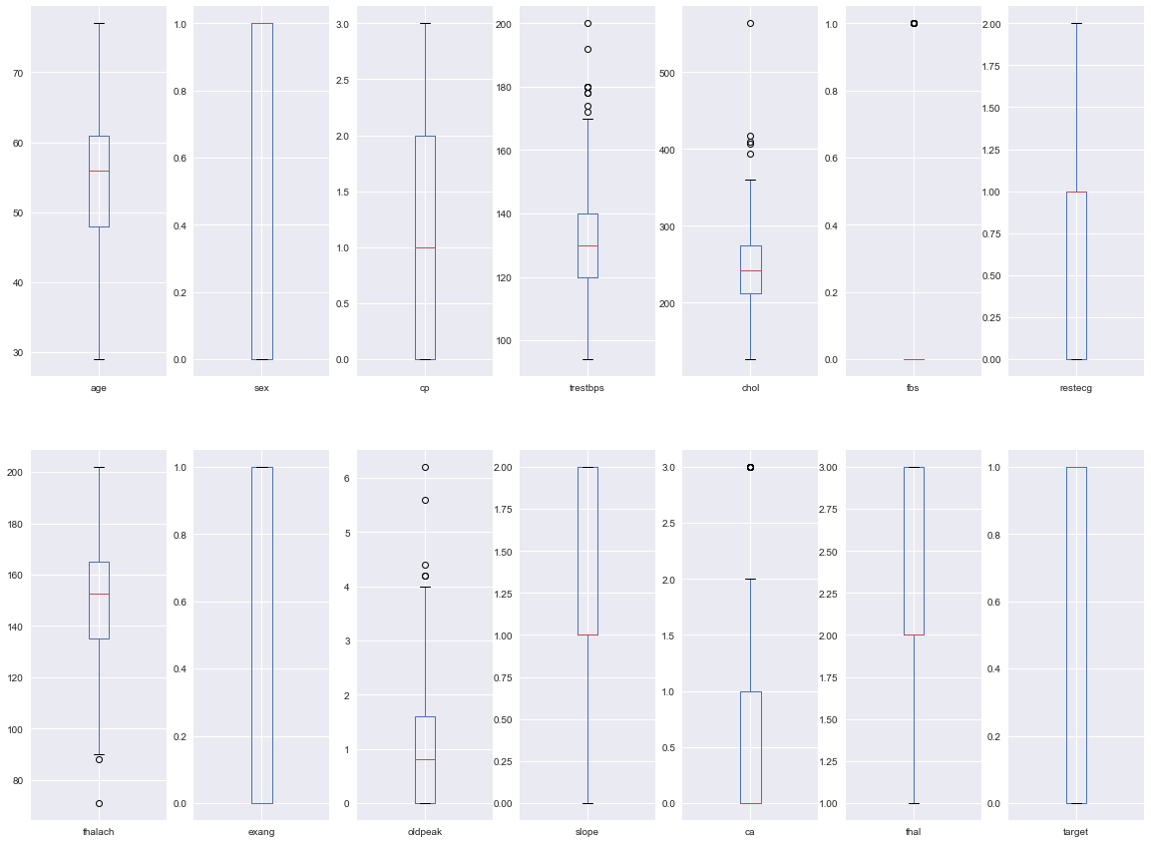
count 303.000000
mean 245.986799
std 48.018482
min 126.000000
25% 212.000000

50% 242.500000
75% 274.000000
max 417.000000
Name: chol, dtype: float64
# Checking For Outliers.
df.plot(kind='box',subplots=True,sharex=False,sharey=False,layout=(2,7),figsize=(20,15))
age AxesSubplot(0.125,0.536818;0.0945122x0.343182)
sex AxesSubplot(0.238415,0.536818;0.0945122x0.343182)
cp AxesSubplot(0.351829,0.536818;0.0945122x0.343182)
trestbps AxesSubplot(0.465244,0.536818;0.0945122x0.343182)
chol AxesSubplot(0.578659,0.536818;0.0945122x0.343182)
fbs AxesSubplot(0.692073,0.536818;0.0945122x0.343182)
restecg AxesSubplot(0.805488,0.536818;0.0945122x0.343182)
thalach AxesSubplot(0.125,0.125;0.0945122x0.343182)
exang AxesSubplot(0.238415,0.125;0.0945122x0.343182)
oldpeak AxesSubplot(0.351829,0.125;0.0945122x0.343182)
slope AxesSubplot(0.465244,0.125;0.0945122x0.343182)
ca AxesSubplot(0.578659,0.125;0.0945122x0.343182)
thal AxesSubplot(0.692073,0.125;0.0945122x0.343182)
target AxesSubplot(0.805488,0.125;0.0945122x0.343182)
dtype: object
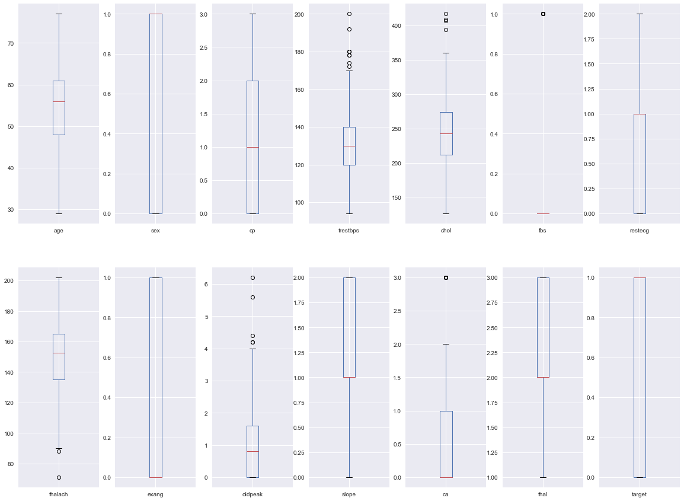

ca = ['0','1','2','3']

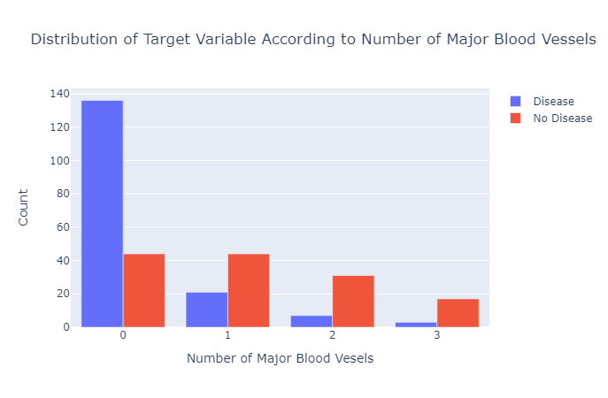
ca_y0 = df[df['target']==0].ca.value_counts()
ca_y1 = df[df['target']==1].ca.value_counts()
no_disease_data = go.Bar(name='No Disease',x=ca,y=ca_y0)
disease_data = go.Bar(name='Disease',x=ca,y=ca_y1)
fig = go.Figure(data=[disease_data,no_disease_data])
fig.update_xaxes(title_text='Number of Major Blood Vesels')
fig.update_yaxes(title_text='Count')
fig.update_layout(title_text='Distribution of Target Variable According to Number of Major Blood Vessels',barmode='group')
fig.show()

Multicollinearity
sns.set(style='dark')
plt.figure(figsize=(15,10))
sns.heatmap(df.corr(),annot=True,linewidths=0.5,cmap='Greens')
plt.title('Corelation Between Variables',fontsize=30)
plt.show()
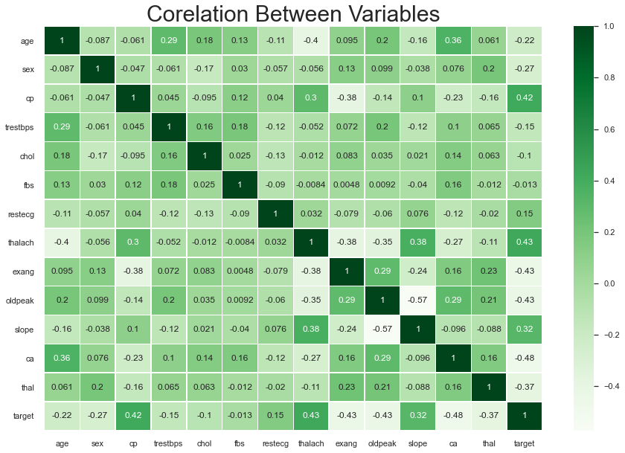

y = df['target']
X = df.drop('target',axis=1)
X_train,X_test,y_train,y_test = train_test_split(X,y,test_size=0.2,random_state=0)
scaler = StandardScaler()
X_train = scaler.fit_transform(X_train)
X_test = scaler.transform(X_test)
print(X_train.shape,y_train.shape)
print(X_test.shape,y_test.shape)
(242, 13) (242,)
(61, 13) (61,)

Baseline Prediction
dummy_cls = DummyClassifier(strategy='stratified')
dummy_cls.fit(X_train,y_train)
acc = dummy_cls.score(X_test,y_test)
print("Baseline Accuracy is :",acc)
Baseline Accuracy is : 0.4098360655737705
def calculateScores(y_pred,y_test=y_test):
acc = metrics.accuracy_score(y_test,y_pred)
f1 = metrics.f1_score(y_test,y_pred)
conf = confusion_matrix(y_test,y_pred)
report = classification_report(y_test,y_pred)
return acc,f1,conf,report
def printScores(acc,f1,conf,report):
print("Test Accuracy Score :\n",acc,"\n")
print("Test f1 Score :\n",f1,"\n")
print("Confusion Matrix :\n",conf,"\n")
print("Classification Report :\n",report,"\n")

Logistic Regression
lr = LogisticRegression()
lr.fit(X_train,y_train)
y_pred_lr = lr.predict(X_test)
acc_lr,f1_lr,conf_lr,report_lr = calculateScores(y_pred_lr)
print Scores(acc_lr,f1_lr,conf_lr,report_lr)
Test Accuracy Score :
0.8852459016393442
Test f1 Score :
0.8985507246376812
Confusion Matrix :
[[23 4]
[ 3 31]]
Classification Report:
precision recall f1-score support
0.0 0.88 0.85 0.87 27
1.0 0.89 0.91 0.90 34
accuracy 0.89 61
macro avg 0.89 0.88 0.88 61
weighted avg 0.89 0.89 0.88 61

K-Nearest Neighbours Classifier
knn = KNeighborsClassifier()
knn.fit(X_train,y_train)
y_pred_knn = knn.predict(X_test)
acc_knn,f1_knn,conf_knn,report_knn = calculateScores(y_pred_knn)
print Scores(acc_knn,f1_knn,conf_knn,report_knn)
Test Accuracy Score:
0.819672131147541
Test f1 Score:
0.8405797101449276
Confusion Matrix:
[[21 6]
[ 5 29]]
Classification Report:
precision recall f1-score support
0.0 0.81 0.78 0.79 27
1.0 0.83 0.85 0.84 34
accuracy 0.82 61
macro avg 0.82 0.82 0.82 61
weighted avg 0.82 0.82 0.82 61

Decision Tree
des = DecisionTreeClassifier()
des.fit(X_train,y_train)
y_pred_des = des.predict(X_test)
acc_des,f1_des,conf_des,report_des = calculateScores(y_pred_des)
printScores(acc_des,f1_des,conf_des,report_des)
Test Accuracy Score:
0.7868852459016393
Test f1 Score:
0.7999999999999999
Confusion Matrix:
[[22 5]
[ 8 26]]
Classification Report:
precision recall f1-score support
0.0 0.73 0.81 0.77 27
1.0 0.84 0.76 0.80 34
accuracy 0.79 61
macro avg 0.79 0.79 0.79 61
weighted avg 0.79 0.79 0.79 61
ran = RandomForestClassifier()
ran.fit(X_train,y_train)
y_pred_ran = ran.predict(X_test)
acc_ran,f1_ran,conf_ran,report_ran = calculateScores(y_pred_ran)
printScores(acc_ran,f1_ran,conf_ran,report_ran)
Test Accuracy Score:
0.8360655737704918
Test f1 Score:
0.8571428571428571
Confusion Matrix :
[[21 6]
[ 4 30]]
Classification Report :
precision recall f1-score support
0.0 0.84 0.78 0.81 27
1.0 0.83 0.88 0.86 34
accuracy 0.84 61
macro avg 0.84 0.83 0.83 61
weighted avg 0.84 0.84 0.84 61

Extreme Gradient Boosting
xgb = XGBClassifier(use_label_encoder=False,eval_metric='error')
xgb.fit(X_train,y_train)
y_pred_xgb = xgb.predict(X_test)
acc_xgb,f1_xgb,conf_xgb,report_xgb = calculateScores(y_pred_xgb)
printScores(acc_xgb,f1_xgb,conf_xgb,report_xgb)
Test Accuracy Score :
0.819672131147541
Test f1 Score :
0.8358208955223881
Confusion Matrix :
[[22 5]
[ 6 28]]
Classification Report :
precision recall f1-score support
0.0 0.79 0.81 0.80 27
1.0 0.85 0.82 0.84 34
accuracy 0.82 61
macro avg 0.82 0.82 0.82 61
weighted avg 0.82 0.82 0.82 61

Naive Bayes
nb = GaussianNB()
nb.fit(X_train,y_train)
y_pred_nb = nb.predict(X_test)
acc_nb,f1_nb,conf_nb,report_nb = calculateScores(y_pred_nb)
printScores(acc_nb,f1_nb,conf_nb,report_nb)
Test Accuracy Score :
0.8524590163934426
Test f1 Score :
0.8732394366197184
Confusion Matrix:
[[21 6]
[ 3 31]]
Classification Report:
precision recall f1-score support
0.0 0.88 0.78 0.82 27
1.0 0.84 0.91 0.87 34
accuracy 0.85 61
macro avg 0.86 0.84 0.85 61
weighted avg 0.85 0.85 0.85 61

Support Vector Classifier
svc = SVC()
svc.fit(X_train,y_train)
y_pred_svc = svc.predict(X_test)
acc_svc,f1_svc,conf_svc,report_svc = calculateScores(y_pred_svc)
printScores(acc_svc,f1_svc,conf_svc,report_svc)
Test Accuracy Score:
0.8852459016393442
Test f1 Score:
0.9014084507042254
Confusion Matrix :
[[22 5]
[ 2 32]]
Classification Report :
precision recall f1-score support
0.0 0.92 0.81 0.86 27
1.0 0.86 0.94 0.90 34
accuracy 0.89 61
macro avg 0.89 0.88 0.88 61
weighted avg 0.89 0.89 0.88 61
model_df = pd.DataFrame({'model':['Logistic Regression','Random Forest','Extreme Gradient Boost','K-Nearest Neighbour','Decision Tree','Naive Bayes','Support Vector Classifier'],
'Accuracy':[acc_lr,acc_ran,acc_xgb,acc_knn,acc_des,acc_nb,acc_svc]})
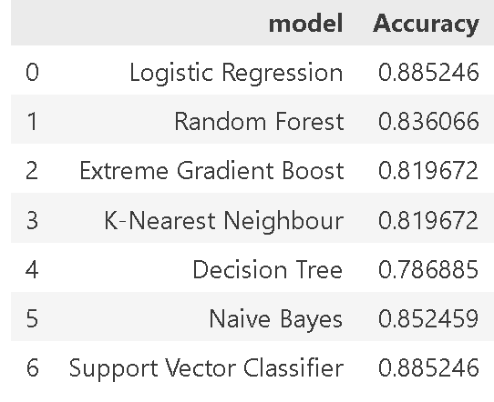
model_df

feature_importance = abs(lr.coef_[0])
feature_importance = 100.0 *(feature_importance/feature_importance.max())
sorted_idx = np.argsort(feature_importance)
pos = np.arange(sorted_idx.shape[0]) + 0.5
featfig = plt.figure()
featax = featfig.add_subplot(1,1,1)
featax.barh(pos,feature_importance[sorted_idx],align='center')
featax.set_yticks(pos)
featax.set_yticklabels(np.array(X.columns)[sorted_idx],fontsize=10)
featax.set_xlabel('Relative Feature Importance')
plt.tight_layout()
plt.show()
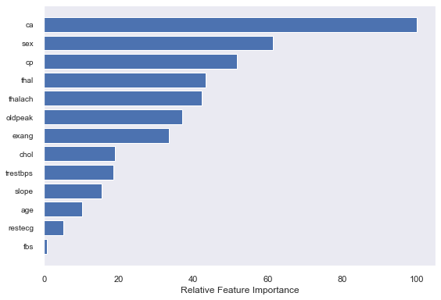

variable ca was the most influential in predicting whether an individual had heart disease or not. Variable ca referred the the number of major vessels (0–3) colored by a flourosopy. The lower the number of major blood vessels, reduces the amount of blood flowing to the heart, increasing the presence of heart disease.

Ensembling
scv = StackingCVClassifier(classifiers=[lr,nb,svc],meta_classifier=nb)
scv.fit(X_train,y_train)
y_pred_scv = scv.predict(X_test)
acc_scv,f1_scv,conf_scv,report_scv = calculateScores(y_pred_scv)
printScores(acc_scv,f1_scv,conf_scv,report_scv)
Test Accuracy Score :
0.8852459016393442
Test f1 Score :
0.8985507246376812
Confusion Matrix:
[[23 4]
[ 3 31]]
Classification Report:
precision recall f1-score support
0.0 0.88 0.85 0.87 27
1.0 0.89 0.91 0.90 34
accuracy 0.89 61
macro avg 0.89 0.88 0.88 61
weighted avg 0.89 0.89 0.88 61
classes = ['No Disease','Disease']
def plot_confusion_matrix(cm,classes,normalize=False,title='Confusion Matrix(Ensemble)',cmap=plt.cm.Reds):
if normalize:
cm = cm.astype('float')/cm.sum(axis=1)[:,np.newaxis]
print("Normalized Confusion Matrix")
else:
print("Confusion Matrix, without Normalization")
plt.imshow(cm,interpolation='nearest',cmap=cmap)
plt.title(title)
plt.colorbar()
tick_marks = np.arange(len(classes))
plt.xticks(tick_marks,classes,rotation=45)
plt.yticks(tick_marks,classes)
fmt = '.2f' if normalize else 'd'
thres = cm.max()/2.0
for i,j in itertools.product(range(cm.shape[0]),range(cm.shape[1])):
plt.text(j,i,format(cm[i,j],fmt),horizontalalignment='center',color='white' if cm[i,j]>thres else 'black')
plt.tight_layout()
plt.ylabel('True Label')
plt.xlabel('Predicted Label')
plot_confusion_matrix(conf_scv,classes)
Confusion Matrix, without Normalization

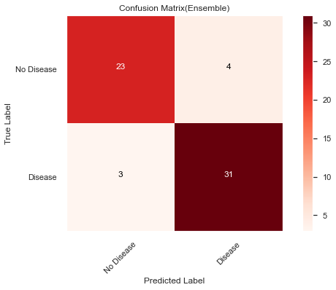

Plotting ROC Curve
y_pred = [y_pred_lr,y_pred_knn,y_pred_des,y_pred_ran,y_pred_xgb,y_pred_nb,y_pred_svc,y_pred_scv]
model_name = ['Logistic Regression','KNN','Decision Tree','Random Forest','XGB','Naive Bayes','Support Vector Classifier','Ensemble']
curve = []
for y_pred_ in y_pred:
curve.append(roc_curve(y_test,y_pred_))
plt.plot([0,1],[0,1],'k--')
for i in range(len(model_name)):
plt.plot(curve[i][0],curve[i][1],label=model_name[i])
plt.xlabel('False Positive Rate')
plt.ylabel('True Positive Rate')
plt.legend()
plt.title('ROC Curve No GridSearch')
plt.show()

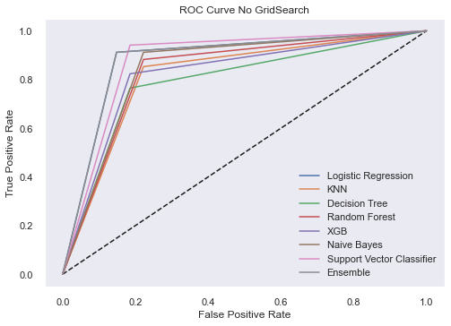

for i in range(len(model_name)):
print("AUC ",model_name[i],":",roc_auc_score(y_test,y_pred[i]))
AUC Logistic Regression : 0.8818082788671023
AUC KNN : 0.815359477124183
AUC Decision Tree : 0.789760348583878
AUC Random Forest : 0.8300653594771241
AUC XGB : 0.8191721132897605
AUC Naive Bayes : 0.8447712418300652
AUC Support Vector Classifier : 0.8779956427015251
AUC Ensemble : 0.8818082788671023

GRID SEARCH CV

Logistic Regression Grid
param_grid_lr = {'penalty':['l1','l2'],
'C':np.logspace(-4,4,20)}
grid_search_lr = GridSearchCV(estimator=lr,param_grid = param_grid_lr,cv=7,scoring='accuracy',n_jobs=-1)
grid_search_lr.fit(X_train,y_train)
lr_params = grid_search_lr.best_params_
print(lr_params)
{'C': 0.615848211066026, 'penalty': 'l2'}
lr_grid = LogisticRegression(**lr_params)
lr_grid.fit(X_train,y_train)
y_pred_lr_grid = lr_grid.predict(X_test)
acc_lr_grid,f1_lr_grid,conf_lr_grid,report_lr_grid = calculateScores(y_pred_lr_grid)
printScores(acc_lr_grid,f1_lr_grid,conf_lr_grid,report_lr_grid)
Test Accuracy Score :
0.8852459016393442
Test f1 Score :
0.8985507246376812
Confusion Matrix :
[[23 4]
[ 3 31]]
Classification Report :
precision recall f1-score support
0.0 0.88 0.85 0.87 27
1.0 0.89 0.91 0.90 34
accuracy 0.89 61
macro avg 0.89 0.88 0.88 61
weighted avg 0.89 0.89 0.88 61
Extreme Gradient Boosting Grid
param_grid_xgb = {'max_depth':[3,4,5],
'learning_rate':[0.1,0.01,0.001],
'n_estimators':[9,10,11,12],
'seed':[10,20,25]}
grid_search_xgb = GridSearchCV(estimator=xgb,param_grid=param_grid_xgb,cv=7,scoring='accuracy',n_jobs=-1)
grid_search_xgb.fit(X_train,y_train)
xgb_params = grid_search_xgb.best_params_
print(xgb_params)
{'learning_rate': 0.1, 'max_depth': 5, 'n_estimators': 9, 'seed': 10
xgb_grid = XGBClassifier(**xgb_params,use_label_encoder=False,eval_metric='error')
xgb_grid.fit(X_train,y_train)
y_pred_xgb_grid = xgb_grid.predict(X_test)
acc_xgb_grid,f1_xgb_grid,conf_xgb_grid,report_xgb_grid = calculateScores(y_pred_xgb_grid)
printScores(acc_xgb_grid,f1_xgb_grid,conf_xgb_grid,report_xgb_grid)
Test Accuracy Score:
0.819672131147541
Test f1 Score :
0.8405797101449276
Confusion Matrix :
[[21 6]
[ 5 29]]
Classification Report :
precision recall f1-score support
0.0 0.81 0.78 0.79 27
1.0 0.83 0.85 0.84 34
accuracy 0.82 61
macro avg 0.82 0.82 0.82 61
weighted avg 0.82 0.82 0.82 61
Naive Bayes Grid
param_grid_nb = {'var_smoothing':np.logspace(0,-20,num=2)}
grid_search_nb = GridSearchCV(estimator=nb,param_grid=param_grid_nb,scoring='accuracy')
grid_search_nb.fit(X_train,y_train)
nb_params = grid_search_nb.best_params_
print(nb_params)
{'var_smoothing': 1e-20}
nb_grid = GaussianNB(**nb_params)
nb_grid.fit(X_train,y_train)
y_pred_nb_grid = nb_grid.predict(X_test)
acc_nb_grid,f1_nb_grid,conf_nb_grid,report_nb_grid = calculateScores(y_pred_nb_grid)
printScores(acc_nb_grid,f1_nb_grid,conf_nb_grid,report_nb_grid)
Test Accuracy Score :
0.8524590163934426
Test f1 Score :
0.8732394366197184
Confusion Matrix :
[[21 6]
[ 3 31]]
Classification Report :
precision recall f1-score support
0.0 0.88 0.78 0.82 27
1.0 0.84 0.91 0.87 34
accuracy 0.85 61
macro avg 0.86 0.84 0.85 61
weighted avg 0.85 0.85 0.85 61
SVC Grid
param_grid_svc = {'kernel':['linear','rbf','poly'],
'C':[1,1.5,2],
'class_weight':['balanced']
}
grid_search_svc =
GridSearchCV(estimator=svc,param_grid=param_grid_svc,cv=7,scoring='accuracy',n_jobs=-1)
grid_search_svc.fit(X_train,y_train)
svc_params = grid_search_svc.best_params_
print(svc_params)
{'C': 1, 'class_weight': 'balanced', 'kernel': 'rbf'}
svc_grid = SVC(**svc_params,probability=True)
svc_grid.fit(X_train,y_train)
y_pred_svc_grid = svc_grid.predict(X_test)
acc_svc_grid,f1_svc_grid,conf_svc_grid,report_svc_grid = calculateScores(y_pred_svc_grid)
printScores(acc_svc_grid,f1_svc_grid,conf_svc_grid,report_svc_grid)
Test Accuracy Score:
0.8852459016393442
Test f1 Score :
0.8985507246376812

Confusion Matrix:
[[23 4]
[ 3 31]]
Classification Report:
precision recall f1-score support
0.0 0.88 0.85 0.87 27
1.0 0.89 0.91 0.90 34
accuracy 0.89 61
macro avg 0.89 0.88 0.88 61
weighted avg 0.89 0.89 0.88 61

K-Nearest Neighbour Grid
param_grid_knn = {'n_neighbors':[5,10,15,20],
'weights':['uniform','distance']}
grid_search_knn = GridSearchCV(estimator=knn,param_grid=param_grid_knn,cv=3,scoring='f1',n_jobs=-1)
grid_search_knn.fit(X_train,y_train)
knn_params = grid_search_knn.best_params_
print(knn_params)
{'n_neighbors': 20, 'weights': 'uniform'}

knn_grid = KNeighborsClassifier(**knn_params)
knn_grid.fit(X_train,y_train)
y_pred_knn_grid = knn_grid.predict(X_test)
acc_knn_grid,f1_knn_grid,conf_knn_grid,report_knn_grid = calculateScores(y_pred_knn_grid)
printScores(acc_knn_grid,f1_knn_grid,conf_knn_grid,report_knn_grid)
Test Accuracy Score:
0.819672131147541
Test f1 Score:
0.8533333333333334
Confusion Matrix:
[[18 9]
[ 2 32]]

Classification Report:
precision recall f1-score support
0.0 0.90 0.67 0.77 27
1.0 0.78 0.94 0.85 34
accuracy 0.82 61
macro avg 0.84 0.80 0.81 61
weighted avg 0.83 0.82 0.81 61

Decision Tree Grid
param_grid_des = {'criterion':['gini','entropy'],
'max_depth':[2,3,4,5,6],
'min_samples_leaf':[6,7,8],
'max_leaf_nodes':[12,13,14,15],
'max_features':['auto','sqrt','log2'],
'random_state':[42,52,62]
}
grid_search_des =
GridSearchCV(estimator=des,param_grid=param_grid_des,cv=7,scoring='accuracy',n_jobs=-1)
grid_search_des.fit(X_train,y_train)
des_params = grid_search_des.best_params_
print(des_params)
{'criterion': 'gini', 'max_depth': 6, 'max_features': 'auto', 'max_leaf_nodes': 13, 'min_samples_leaf': 7, 'random_state': 52}
des_grid = DecisionTreeClassifier(**des_params)
des_grid.fit(X_train,y_train)
y_pred_des_grid = des_grid.predict(X_test)
acc_des_grid,f1_des_grid,conf_des_grid,report_des_grid = calculateScores(y_pred_des_grid)
printScores(acc_des_grid,f1_des_grid,conf_des_grid,report_des_grid)
Test Accuracy Score:
0.7868852459016393
Test f1 Score:
0.7868852459016393
Confusion Matrix:
[[24 3]
[10 24]]
Classification Report :
precision recall f1-score support
0.0 0.71 0.89 0.79 27
1.0 0.89 0.71 0.79 34
accuracy 0.79 61
macro avg 0.80 0.80 0.79 61
weighted avg 0.81 0.79 0.79 61

Random Forest Grid
param_grid_ran = {
'criterion':['gini','entropy'],
'max_leaf_nodes':[50,60,70],
'max_depth':[4,5,6],
'max_features':['auto','log2']
}
grid_search_ran = GridSearchCV(estimator=ran,param_grid=param_grid_ran,cv=5,scoring='accuracy')
grid_search_ran.fit(X_train,y_train)
ran_params = grid_search_ran.best_params_
print(ran_params)
{'criterion': 'entropy', 'max_depth': 6, 'max_features': 'auto', 'max_leaf_nodes': 50}
ran_grid = RandomForestClassifier(**ran_params)
ran_grid.fit(X_train,y_train)
y_pred_ran_grid = ran_grid.predict(X_test)
acc_ran_grid,f1_ran_grid,conf_ran_grid,report_ran_grid = calculateScores(y_pred_ran_grid)
printScores(acc_ran_grid,f1_ran_grid,conf_ran_grid,report_ran_grid)
Test Accuracy Score:
0.8524590163934426
Test f1 Score:
0.8695652173913043
Confusion Matrix:
[[22 5]
[ 4 30]]
Classification Report:
precision recall f1-score support
0.0 0.85 0.81 0.83 27
1.0 0.86 0.88 0.87 34
accuracy 0.85 61
macro avg 0.85 0.85 0.85 61
weighted avg 0.85 0.85 0.85 61

Grid Search Model Evaluation
model_grid_df = pd.DataFrame({'Model': ['Logistic Regression','Random Forest','Extreme Gradient Boost', 'K-Nearest Neighbour','Decision Tree','Naive Bayes', 'Support Vector Classifier'], 'Accuracy':[acc_lr_grid,acc_ran_grid,acc_xgb_grid,acc_knn_grid,acc_des_grid,acc_nb_grid,acc_svc_grid]})
model_grid_df
Model Accuracy
0 Logistic Regression 0.885246
1 Random Forest 0.852459
2 Extreme Gradient Boost 0.819672
3 K-Nearest Neighbour 0.819672
4 Decision Tree 0.786885
5 Naive Bayes 0.852459
6 Support Vector Classifier 0.885246
scv_grid = StackingCVClassifier(classifiers=[lr_grid,nb_grid,svc_grid],meta_classifier=lr_grid,random_state=22)
scv_grid.fit(X_train,y_train)
y_pred_scv_grid = scv_grid.predict(X_test)
acc_scv_grid,f1_scv_grid,conf_scv_grid,report_scv_grid = calculateScores(y_pred_scv_grid)
printScores(acc_scv_grid,f1_scv_grid,conf_scv_grid,report_scv_grid)
Test Accuracy Score:
0.8524590163934426
Test f1 Score:
0.8732394366197184
Confusion Matrix:
[[21 6]
[ 3 31]]
Classification Report:
precision recall f1-score support
0.0 0.88 0.78 0.82 27
1.0 0.84 0.91 0.87 34
accuracy 0.85 61
macro avg 0.86 0.84 0.85 61
weighted avg 0.85 0.85 0.85 61
plot_confusion_matrix(conf_scv_grid,classes,cmap=plt.cm.Greens)
Confusion Matrix, without Normalization.
